Name: _______________________ ID: _______________________

**Analytical Chemistry II – Quiz (1st March, 2022)**

1) Write down the formula for *V*1 in the circuit below. The formula should relate *V*1 with *V*, *R*1, *R*2, and *R*3.

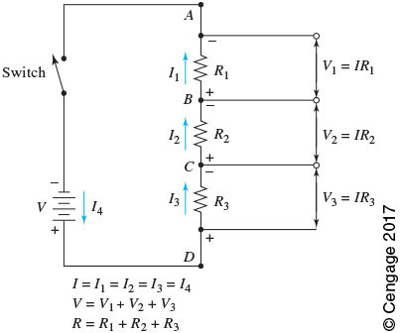

2) - What is bias of analytical method? (1 sentence)

- Write general equation expressing bias. Explain the meaning of all symbols.

Bias provides a measure of the systematic error (accuracy) of an analytical method.

$$=-$$

where: – mean concentration of an analyte; – true value.